

**TECHNICAL UNIVERSITY OF OSTRAVA**

VYSOKÁ ŠKOLA BÁŇSKÁ V OSTRAVĚ

**FACULTY OF ELECTRICAL ENGINEERING AND COMPUTER SCIENCE**

FAKULTA ELEKTROTECHNIKY A INFORMAČNÍCH VĚD

**DEVELOPMENT OF MODERN OF WEB APPLICATIONS**VÝVOJ MODERNÍCH WEBOVÝCH APLIKACÍ

**BACHELOR’S THESIS**

BAKALÁŘSKÁ PRÁCE

**AUTHOR: Nguyen Thanh Tuan**

AUTOR PRÁCE

**SUPERVISOR: Ing. Michal Radecký, Ph.D.**

VEDOUCÍ PRÁCE

**OSTRAVA 2022**

I would like to thank Ing. Michal Radecký, Ph.D. for his guidance, professional support for me to carry out my bachelor's thesis, and useful advices to carry out this thesis.

**ABSTRACT**

The aim of this thesis focuses on nowadays platforms of web applications development. This thesis gives manual, how to select a proper technology framework and how to use it. Besides, with the variety of website development, programmers or designers can self-study, research and develop their own products, students can understand the daily development of web development. web application development platforms and may be updated from time to time.

**KEYWORD**

HTML, CSS, JavaScript, React, web applications development, framework

**ABSTRAKTNÍ**

Tato práce se zaměřuje na současné platformy vývoje webových aplikací. Tato práce poskytuje návod, jak vybrat správný technologický rámec a jak jej používat. Kromě toho, s rozmanitostí vývoje webových stránek, programátoři nebo designéři mohou samostudium, výzkum a vývoj vlastních produktů, studenti mohou pochopit každodenní vývoj vývoje webových aplikací. platformy pro vývoj webových aplikací a mohou být čas od času aktualizovány.

**KLÍČOVÉ SLOVO**

HTML, CSS, JavaScript, React, vývoj webových aplikací, rámec

**List of symbols and abbreviations**

HTML - Hyper Text Markup Language

CSS - Cascading Style Sheet

JS - JavaScript

AJAX - Asynchronous JavaScript and XML

JSX - JavaScript XML

TS - TypeScript

DOM - Document Object Model

API - Application Programming Interface

CDN - Content Delivery Network

UI - User Interface

XHTML - eXtensible Hyper Text Markup Language

**Contents**

1 INTRODUCTION 6

2 WEB DEVELOPMENT FRAMEWORK 7

2.1 What is “web framework” ? 7

2.2 Front-end framework 7

2.2.1 HTML5 8

2.2.2 CSS3 15

2.2.3 JavaScript 28

3 WAY OF WEB APPLICATION DEVELOPMENT 34

3.1 Operating system 34

3.2 Framework 34

3.2.1 HTML5 34

3.2.2 ReactJS 34

3.3 SASS 35

3.4 Tool and other software 35

3.4.1 Redux 35

3.4.2 Photoshop 35

4 CASE STUDY 36

4.1 Index Page 36

4.2 Product Page 37

4.3 Product Detail 37

4.4 Cart Page 38

5 IMPLEMENTATION 39

5.1 Index page 39

5.2 Product page 41

5.3 Detail page 44

5.4 Cart page 45

5.5 Other Important Components 47

5.5.1 Layout 47

5.5.2 Header 48

5.5.3 Footer 49

6 EVALUATION 50

7 CONCLUSION 52

# INTRODUCTION

Technology is always changing over time, every day that passes there may be a new technology born. Web too, web technology also changes over time and there is always a certain change to bring more optimization, modernity and convenience. Nowadays, many frameworks are born with more convenience in usage and implementation such as React, Vue, ... Or frameworks that are very familiar to us like basic HTML5 (HTML, CSS, JavaScript). As students who learn basic programming, you can learn C language because it is the first programming language, but today you can also choose C#, Java, C++, ... for the first programming language Well, today's web applications are ours. There are also many choices of frameworks like React, Vue, Angular, ...

With a full analysis and understanding of frameworks, users will find and choose the right framework to build websites from a personal perspective.

Today with many frameworks appearing and popular, along with the support of the community to strengthen and develop frameworks, we can also be more confident in the process of using those frameworks because when we have If there are difficulties or problems while using, a strong community with many experienced programmers will make it easier for us to fix and overcome.

Therefore, this thesis will focus on analyzing web application development platforms, giving evidences, advantages, disadvantages, which are the most popular, downloaded, and popular platforms, …, and provides readers with basic usage of some popular and convenient technology frameworks.

The main source of reference and content for this thesis is used on w3schools and I also rely on my experience as a designer.

# WEB DEVELOPMENT FRAMEWORK

## What is “web framework”?

Framework are pre-written pieces of code that make up a set of frameworks and packaged programming libraries. They provide built-in features like mockups, APIs, and other elements to simplify the development of rich, dynamic web applications. The frameworks are like we have a pre-made house frame with the basic foundation, you just need to build and interior as you like.

For example: To create a racing game, programmers will have to create (program) wheels, bodywork, people, roads, ... and then start assembling the creation parts. out space for the game. But if we have the frameworks available, we just need to take them out from the framework and reassemble, it will be fast and save a lot of money.

It can be understood that frameworks are pre-made materials for users to use, and just understanding the rules can create optimal products depending on the perspective of programmers.

Programmers or students just starting to learn web programming can use frameworks to be able to create products according to their personal preferences, just need to understand the operating rules of those frameworks. will be easier to use.

In web development framework, there are two types: Front-end framework and Back-end framework.

## Front-end framework

In simple terms, in web design, the front-end is created by three basic languages, which are HTML, CSS, and JavaScript. Programmers are not just web designers, but must make the designed web applications compatible with other types of devices and screens, possibly different operating systems.

Front-end frameworks are packages of pre-written code to apply. It's like a coding dictionary made to help you quickly perfect your application without having to code it yourself.

In the front-end framework, there are two types of frameworks but can be used together to optimize the application, product and user interface. Those are CSS framework and JS framework.

When it comes to Front-end, users always think of the famous trio of HTML5, CSS and JavaScript and I will focus a lot on the Front-end framework. Figure 1 is a trio of commonly used web programming languages, and since then many different libraries and frameworks have been born and help users choose the right libraries and frameworks for developing applications.

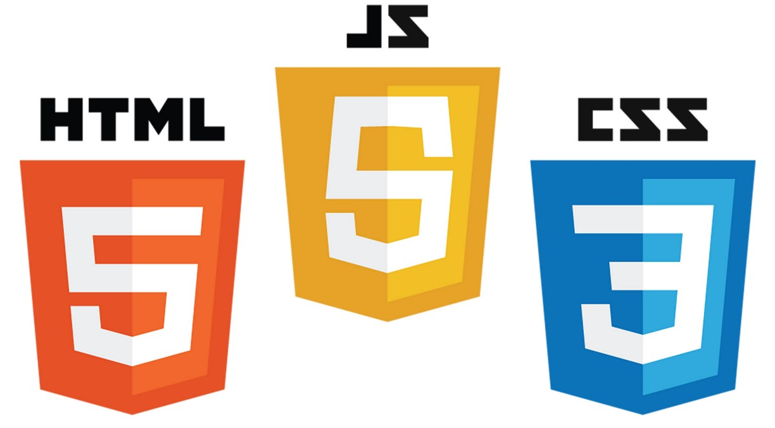Figure 1: HTML5, JS and CSS

### HTML5

#### What is HTML5?

HTML5 is an upgrade of HTML (HyperText Markup Link) which is a quality HyperText Markup Language for web browsers, this is a language that allows creating web pages on many web browsers such as Google Chrome, Microsoft Edge, ... [1]

When HTML was born, the difficulty that programmers faced was that some web browsers would be incompatible or not work well. So different browsers when displaying web pages will always have their own way of working and compatibility, including mobile browsers, tablet browsers, etc. Programmers are always thinking and finding ways so that the HTML works fine on all web browsers without any difficulty. But when the HTML5 version was released, those difficulties have been overcome and provided many features that bring many conveniences and benefits to developers.

#### Features of HTML5

These are the most commonly used and most used features in the apps by students, programmers and developers[1][2].

##### Header and Footer

This is one of two important HTML tags when creating a web page.

* HTML5 Header

Header always appears at the top of the page and usually contains information about buttons, logos, searches, ...

* HTML5 Footer

Footer always appears at the bottom of the page and usually contains information about company information, author information, buttons, contact, ...

How to use Header and Footer:

<header>

<p>Header</p>

</header >

<nav>

<li>Example 1</li>

</nav>

<footer>

<p>Footer</p>

</footer>

Listing 1: Header and Footer in HTML5

Figure 2 is the result of the code above, to help you understand how Header and Footer work.

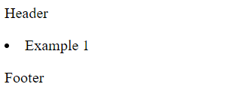

Figure 2: Result of Header and Footer in HTML5

##### Storage in HTML5

* HTML5 Web Storage

With caching in HTML5, a web application can store data and store the data at the client in the user's browser.

Before HTML5, data had always been stored in cookies, each requesting it by the server. With web storage, the data is always secure, safe and the performance of the website is not affected.

* HTML5 Application Cache

HTML5 introduces application caching, which means that web applications are cached and accessible without an internet connection. Helps users ensure their rights when accessing applications offline, not affected by speed and server will not be overloaded if requested.

##### Graphics and media in HTML5

* HTML5 Canvas

Canvas is an HTML tag like other HTML tags, used to draw graphics, and it is built through JavaScript.

The <canvas> tag is just a container, want to use this tag, we will place this tag where you want it to be displayed on the web page. Because this tag is just a container, you must use JavaScript to draw graphics like squares, ... [4]

When using the Canvas tag, we must understand the rules and parameters when drawing graphics and its content. When displayed in the browser, the Canvas will be displayed as a png image.

How to use HTML Canvas:

<canvas id="myCanvas" width="200" height="100" style="border:1px solid #000000;">

</canvas>

Listing 2: Canvas in HTML5

This is a circle drawn with the <canvas> tag, the result is shown in Figure 3



Figure 3: Result of Canvas in HTML5

* HTML5 Vector

To draw vector shapes, we will use SVG tags to do so. SVG stands for SVG stands for Scalable Vector Graphics, is a tag in HTML used to draw complex shapes through JavaScript or pre-drawn vector graphics such as circles, lines, ... Because this is vector graphic image so when we perform zooming in/out of a web page, the image will not be broken, for fixed pixel graphic images, it will always be broken when zooming in/out.

HTML5 SVG is a feature that makes it possible for many developers to draw personalized graphics such as octagons, parallelograms, without having to go through 3rd party software. Besides, SVG can help Users create animations like GIFs, or insert images. Almost all web browsers can display SVG images like other image types JPEG, PNG, etc. For computers or operating systems that still use IE (Internet Explorer), user must to install Adobe SVG Viewer, which can view SVG images on IE.

How to use HTML Vector:

<svg width="300" height="200">

<polygon points="100,10 40,198 190,78 10,78 160,198"

style="fill:red;stroke:black;stroke-width:6;"/>

</svg>

Listing 3: SVG in HTML5

This is a star drawn with SVG tags on Figure 4, and in the tag will have information like height, width, ... and can be drawn with other vector graphics tags.



Figure 4: Result of SVG in HTML5

* HTML5 Video

The Video tag is used to display videos on a web page[6]. Depending on the arrangement of each user, you can adjust the video size to fit the viewer.

Users should add width and height attributes to the tag to avoid when the video is flickering while the video is playing. The video will always show full screen, stop, play, pause and volume properties.

<video width="360" height="280" controls>

<source src="movie.mp4" type="video/mp4">

</video>

Listing 4: Video in HTML5

Here is the video displayed on the website at 360x280 on Figure 5. Depending on the quality and size of the user-generated video. If the video size is small and enlarged, the video will be broken and difficult to watch. And currently HTML Audio only supports 3 audio files format: .mp4, .ogg, .WebM.

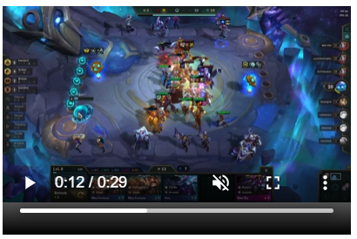

Figure 5: Result of Video in HTML5

* HTML5 Audio

Like the Video tag, the Audio tag also has the same function and display, but only displays audio on the web page. The audio tag has an attribute like "loop" that can only listen to the same sound over and over.

Sound tags are commonly used to make background music for some web pages.

How to use Audio:

<audio controls>

<source src="audio.mp3" type="audio/mpeg">

</audio>

Listing 5: Audio in HTML5

This is the interface that will show the sound on Figure 6, because this is the image in the thesis, we cannot hear what the sound is playing. But users can try with their products, the properties are also clearly displayed on the audio interface such as stopping, increasing / decreasing the volume. And currently HTML Audio only supports 3 audio files format: .mp3, .ogg, .wav.

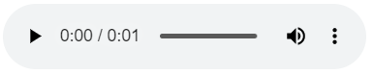

Figure 6: Result of Audio in HTML5

##### New syntax elements in HTML5

From early HTML versions. Gradually versions of HTML are updated, and with each version there are updates and improvements that make the language more convenient. HTML5 is an example, new tags, programming methods, ... all become neater and more convenient, so the operations help users perform better.

##### HTML5 Geolocation API

The HTML5 Geolocation API allows users to share their location, so if the user approves, the feature will only be available. JavaScript can capture the computer's latitude and longitude information and send it to the web server.

That's why when we use Google Maps, we always know where we are, and the server will ask if we agree to share our location.

Today, browsers and mobile devices always have API support for location sharing.

#### Advantage of HTML5

* Maximized source code and new bookmark tag

HTML5 is the latest version, the version is considered the most optimal. HTML5 is a version that has improved the difficulties and disadvantages of previous versions clearly. The first and most basic features are the cards. HTML5 has provided users with many new and convenient things, from content tags (title, aside, article, ...) to multimedia tags (video, audio, ...). In addition, HTML5 also gives users the ability to clearly allocate positions through surveys and the way that users design a web page must ensure the basic elements (header, footers, ...). Creating tags that can manage locations for a website makes it easier for developers to manage the functions on the site, and visitors also have a positive view of the ease of access. site or use. The <form> tag is a widely used tag, because all functions such as formatting, data validation, ... are integrated directly into the HTML. Old-fashioned technologies like Adobe Flash will no longer be supported.

* Offline Browsing

There is not always internet 24/7, this sometimes also makes users uncomfortable. Offline Browser is a feature that helps to store offline cache in the browser, allowing users to access the website without having to be online. This also makes the site save bandwidth and speed up web browsing.

* Video and Audio tags

In previous versions, developers always had to buy and use software like Adobe Flash Player, Silverlight to embed video or audio in websites and use complex tags like <embed> and <object>. These methods are often not available and cross-browser compatible, and when bugs appear, they are difficult to fix. HTML5 offers positive solutions by integrating libraries and convenient, compact tags, such as <video> and <audio> tags. It is also simpler to use and the attached properties are not difficult for developers, thanks to the features that developers can easily use, reducing the load on resources and the computer will work better and faster.

* Cross-browser operability

HTML5 will provide simple declarations and information, besides, HTML5 will also provide a more robust version of the API than the good ones. HTML5 is considered to work very well on popular browsers such as Chrome, Microsoft Edge, ...

* Canvas for Animation

To reduce complexity and take animation to another level, HTML5 has given a new card named <canvas>. Canvas, a feature embedded in HTML5 and part of the Document Object Model (DOM), opening up many animation options, allowing you to graph, add image effects, team game development route as well as offline, …

* Optimization on mobile devices

Mobile devices are almost indispensable in all cases, so optimizing for mobile devices is one of the advantages of HTML5 for users and developers, helping to display the interface. web application for mobile devices. Interacting, installing, adjusting, and building with HTML5 makes it possible for developers to develop on many different mobile devices and multiple operating systems.

#### Disadvantage of HTML5

HTML5 can be considered as one of the most optimal versions when it has improved the vulnerabilities, complexity, and disadvantages that previous versions have encountered. All browsers have fully supported HTML5 up to the present time, so it can be assessed that HTML5 does not have any significant disadvantages.

#### Structure of HTML5

Figure 7 shows how to use HTML5, the basic functions and implementation of the syntax. The new features in HTML5 mentioned in the above sections will make it easy and convenient for developers to do programming work without having to depend on third-party software or other plugins.

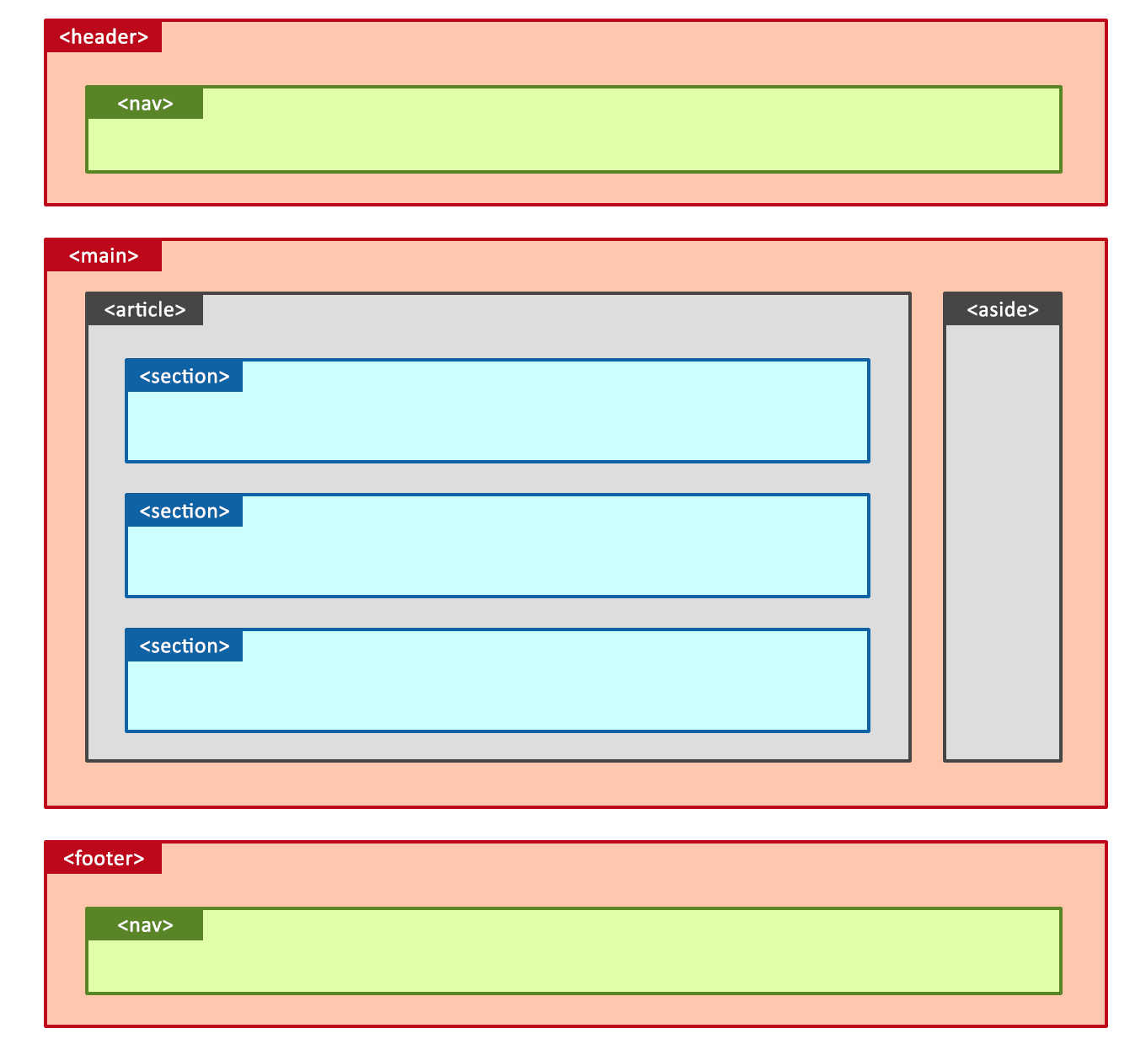

Figure 7: Structure of HTML

### CSS3

#### What Is CSS?

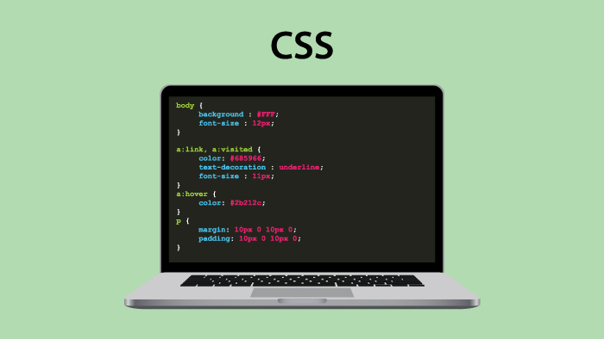

Figure 8: CSS

CSS stands for Cascading Style Sheets which is a style sheet language used to describe the presentation of a web page such as adding colors, effects, formatting, fonts,... and the CSS file is also a file[7][8]. browser support to display the page using HTML. Every website has its own style of interface design, like how to add color in buttons, how to add effects to buttons or cover pages, ... CSS is a file that can improve content accessibility. , which provides more flexibility and control in defining presentation characteristics, allows multiple sites to share formatting by specifying the relevant CSS in a separate .css file, reducing complexity complex and repetitive within that structured content.

In one CSS file, we can adjust for all pages, like want to change the background color for all web pages, fonts, etc. Depending on how the developers want to build the website.

CSS3 can be seen as the latest version of CSS.

#### Features of CSS

##### Font

In CSS, we can add fonts by choosing font-family and choosing the available font templates to use, with so many fonts, developers have a lot of choices to add or refer to Google Fonts for can use.

If developers want to create their own font to use, users can use @font-face and create their own font style. In previous versions of CSS, it was very difficult to create a specific font, or if so, the user's computer would have to have a library of that language to be able to display that font. But with the development and improvement of CSS3, @font-face allows developers to freely express their ideas without worrying about font formatting problems anymore.

How to use CSS Font:

<style>

/*css*/

@font-face {

font-family: myFont;

src: url(sansation_light.woff);

}

.p1 {

font-family: "Lucida Console", "Courier New", monospace;

}

div {

font-family: myFont;

}

</style>

<p class="p1">AAAA</p>

<div>myFont</div>

Listing 6: Font in CSS3

Figure 9 is the result after creating the font with CSS and running it with the HTML to display on the web page.



Figure 9: Result of Font in CSS

##### Background

The CSS Background feature is a trusted and widely used feature that is used to define background effects, allowing background to be applied on any type of HTML element. Developers can apply backgrounds to their website, the common types of backgrounds are usually (image, color, video, ...).

How to use CSS Background:

<style>

body {

/*css*/

background-color: brown;

}

</style>

<body>

Background

</body>

Listing 7: Background in CSS

Figure 10 is the result after creating background with CSS and running it with the HTML to display on the web page.



Figure 10: Result of Background in CSS

##### Animation

* CSS 2D Transform

2D Transform is a property used to handle 2D (two-dimensional) effect motions. Users can use CSS 2D Transform to rotate an object 180 degrees or drag and drop to another HTML tag position. This 2D Transforms effect is one of 4 types of animation effects updated in the CSS3 version.

Here's how to use 2D Transform, just adding a few basic commands:

div {  
  transform: rotate(20deg);  
}

Listing 8: 2D Transform in CSS

* CSS 3D Transform

How to work and use 3D Transform in CSS is the same as 2D Transform, but in 3D will use 3 elements in the axis: x, y and z.

div {  
  transform: rotateX(120deg);  
}

Listing 8: 3D Transform in CSS

* CSS Transitions

CSS Transition allows users to animate a button or an object. Users can specify the time to automatically convert pre-set properties such as changing a button from white to black, changing the effect when the mouse moves on the object.

* CSS Animation

CSS Animation is one of the technologies introduced in the latest version of CSS3. Animation allows users to create animation effects on colors, backgrounds, buttons, ... without using Adobe Flash and JavaScript[10].

##### Color

CSS Color is one of the important technologies used in almost all cases, besides color names such as red, blue, yellow, ... then we will be able to find color types that cannot be specified. through color coding as shown in Figure 11. In HTML, color is always the choice and stimulates creativity besides animation, for designers.

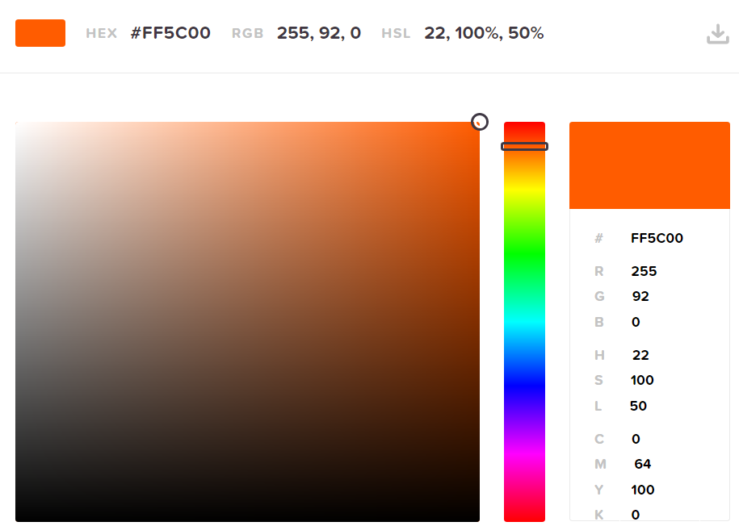

Figure 11: Color in CSS (source: https://htmlcolorcodes.com/)

##### Opacity

##### Pseudo-classes

A Pseudo-Class is used to select elements in CSS3 to define state characteristics. Pseudo-Class technology allows users to add special effects to elements in the HTML tree without having to use JavaScript and usually begins with the ":" character.

    .box{

        background-color: yellow;

    }

/* Pseudo-class*/

    .box:hover{

        background-color: orange;

    }

Listing 9: Pseudo-class in CSS

#### CSS Framework

CSS Framework is a set of CSS source code that has been pre-written with certain functions and declares each function in a separate class, programmers or designers will easily apply the functions to the product, their application by adding the class of the element they want to use on the element they need to apply it to, for example adding a style to a button or menu.

There are many popular and trending CSS Frameworks that many people use, develop and apply to projects such as Bootstrap, Tailwind CSS,...

##### Tailwind CSS

###### What is Tailwind CSS?

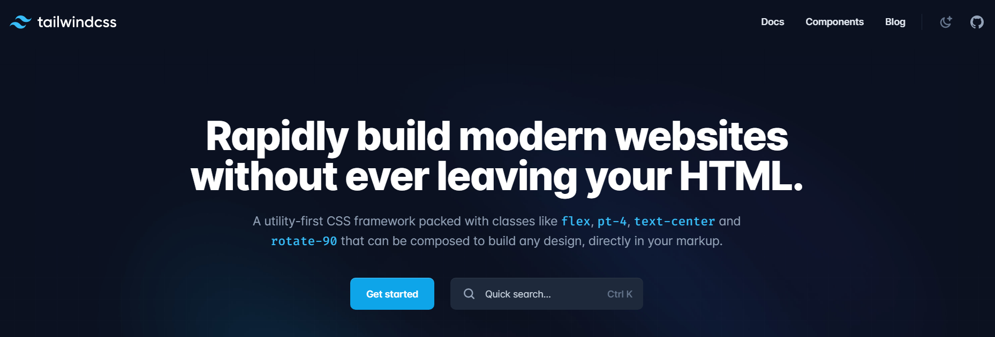

Figure 12: Tailwind CSS (source: <https://tailwindcss.com/>)

Tailwind is a utility-first CSS framework, it has built-in classes that we can use. Tailwind CSS has many classes that cover different CSS properties and importantly, we can easily extend and create new classes with its own classes. With Tailwind, customization is easier than ever. This framework has extremely detailed documentation, covering all the detailed usage of the class and showing various ways of customization.

###### Feature of Tailwind CSS

* Efficiency

When using Tailwind, the system will delete the CSS that the user does not use to save space.

* Component Management

If developers are afraid of writing too long a piece of code in 1 page, when encountering a bug, then developers will lose time finding the error location. So when using Tailwind, developers can break down a website into many components in different documents and combine the documents, making it easier for us to manage and handle when there is a problem. And in terms of interface, this management will become neater.

* Dark mode

Many users and developers today all work in a bright screen, if working at night it will be harmful to eyes if the screen is too bright. So dark mode is a function that helps users switch the interface to black, dark colors so that they can not hurt their eyes.

* Ready-made components[11]

To help users and developers build interfaces quickly, Tailwind developers have built a series of beautiful prototype components that fully meet the design requirements. and functionality, allowing users to use and combine components in a personal style.

* Using Basic CSS Components

If the user wants to use the basic CSS elements without having to integrate the same page with the HTML, the user can use the @apply command to extract it by copying the HTML file to the CSS file and adding the @ directive apply at the top.

###### Advantage of Tailwind CSS

* Save cache

If you are using a traditional CSS, you will feel that you are creating a function, excess layer but you can't know where it is to delete, this will make the buffer much and heavy. So when using Tailwind CSS, this will be removed because you will be done directly on HTML, and will automatically remove the functions, excess layers that you do not use regularly.

* Faster

Tailwind helps users style and write CSS directly on HTML instead of writing on another CSS file. Users can create compositions, interfaces, colors, ... beautiful in a much shorter time than having to do it from the beginning to the end.

* More security

When using Tailwind CSS, users will feel safe and your source code will not be corrupted because you are doing directly in the HTML file. Tailwind has been shown to be a stable and safe framework, because Tailwind is developed by the leading historical techniques, which is why the errors are very rare.

* Other features

Because Tailwind works directly on the HTML file, Tailwind provides the ability to create a response to web applications and remove unused CSS, making memory more compact, economical and easy to manage and modify in large projects.

###### Disadvantage of Tailwind CSS

* Take time to study

Since this is a framework that has already created classes and functions, it is definitely a must for new users to learn and learn more about its usage and scale. Even seasoned developers have to find a way to learn more and memorize new classes. But if we learn a lot and use it fluently, this disadvantage will be overcome. If you're confident and write better basic CSS classes, then Tailwind probably won't be the choice for you, as Tailwind generally helps CSS style faster in the long run.

* Mixed HTML and CSS

This is an advantage of HTML but also a disadvantage, because when using Tailwind CSS, you will write directly in HTML or if you don't want to, you can separate your own CSS file but it will be quite time consuming to use. use.

* Some components are missing

Tailwind doesn't have many styling elements, so if you use Tailwind then you have to manually add those features like buttons, headers, etc. If you already use basic CSS then this shouldn't be difficult for you. , as you can make up for Tailwind quickly without much difficulty.

* Document

Tailwind CSS released its first version in May, 2019. Since it's recently released, the documentation related to Tailwind is still limited, but Tailwind has also made some progress when it comes to guiding users with the tools. video. But if you have a problem, then the user can contact some of the developers or ask a question to the community and the community will answer it for the user.

###### How to use Tailwind CSS

This is how Tailwind CSS works, users can refer to it

<h1 class="text-3xl font-bold underline">

Hello world!

</h1>

Listing 10: How to use Tailwind CSS

##### Bootstrap

###### What is Bootstrap?

Figure 13: Boostrap (source: https://getbootstrap.com/)

Bootstrap is a free and open-source web development framework[12] for faster and easier web development. Bootstrap includes the design of HTML and CSS such as fonts, buttons, images, including the designs of mobile devices, ... Bootstrap also gives users the ability to build functions, classes suitable for individual needs.

Like any other Front-end Framework, Bootstrap includes HTML, CSS and JavaScript components. It adheres to web design standards, allowing you to develop responsive websites at any level.

###### Feature of Bootstrap

Bootstrap is one of the most widely used CSS frameworks. Bootstrap has a lot of features that make this framework famous.

* CSS Custom Properties

CSS custom properties make CSS dynamic and programmable. CSS variables are prefixed with -bs to avoid conflicting CSS of the parties.

* Documentation and Community

The document is informatively updated with a community that has responded to these updates. The information on the user manual, how to add components, ... has been edited and unloaded more clearly. When users encounter difficulties, the Bootstrap community is available to answer and support users and developers.

* Color

The palette in version 5 has been expanded. Developers will have more options, users will be able to style the color they need. The colors related to the contrast index are also updated in this version.

* Icon

Bootstrap has over 1300 icons with open source SVG library. Developers have a lot to choose from for their projects. Icons are very necessary in many projects, Bootstrap has responded very well to developers when gradually updating many of the most popular Icons for users.

###### Advantage of Bootstrap

* Easy to use

For many people who are new to CSS and learning for the first time, it is easy to learn and use Bootstrap. Just download Bootstrap or paste the link in, and users can just apply it instead of having to write a CSS file from scratch.

* Use cross-browser

With Bootstrap's compatibility, users can use it on many browsers such as Chrome, Microsoft Edge, Firefox, ...

* Good documentation

Bootstrap has done a great job of providing documentation for new developers and users who want to learn how to use the framework. With plenty of content about the style that most a website needs. The document also provides information for developers to use, practice and apply to their website.

* Bootstrap CDN

For some CSS Frameworks, users will have to install or download, store, then you only need 1 link that users can put Bootstrap from CDN (Content Delivery Network).

* Grid System

Bootstrap has built many different layouts and grid components. So users will have many options to adjust the components according to their personal preferences with a few simple and quick changes.

###### Disadvantage of Bootstrap

* Override

If you want to adjust some parameters related to the look and feel of your website, you must create a separate parameter with the same name and override the Bootstrap parameter, which may result in duplicates. for many other CSS files, and difficult to control, resulting in your site becoming unprofessional

* Redundancy

If the developers use Bootstrap framework, there will be some functions in the large file, which can slow down your site and burden the server. Users only need some necessary layers to avoid overburdening the server and reduce the size of files.

* Knowledge

Although Bootstrap is easy to use, users need to have a basic knowledge of CSS, and spend some time learning about the components available in Bootstrap. If users do not know about CSS, it will be more difficult to learn compared to other frameworks.

###### How to use Bootstrap

There are many ways to use Bootstrap:

* Users can load Bootstrap directly on the homepage.
* Users can add Bootstrap CSS in the HTML file.

##### Foundation

###### What is Foundation?

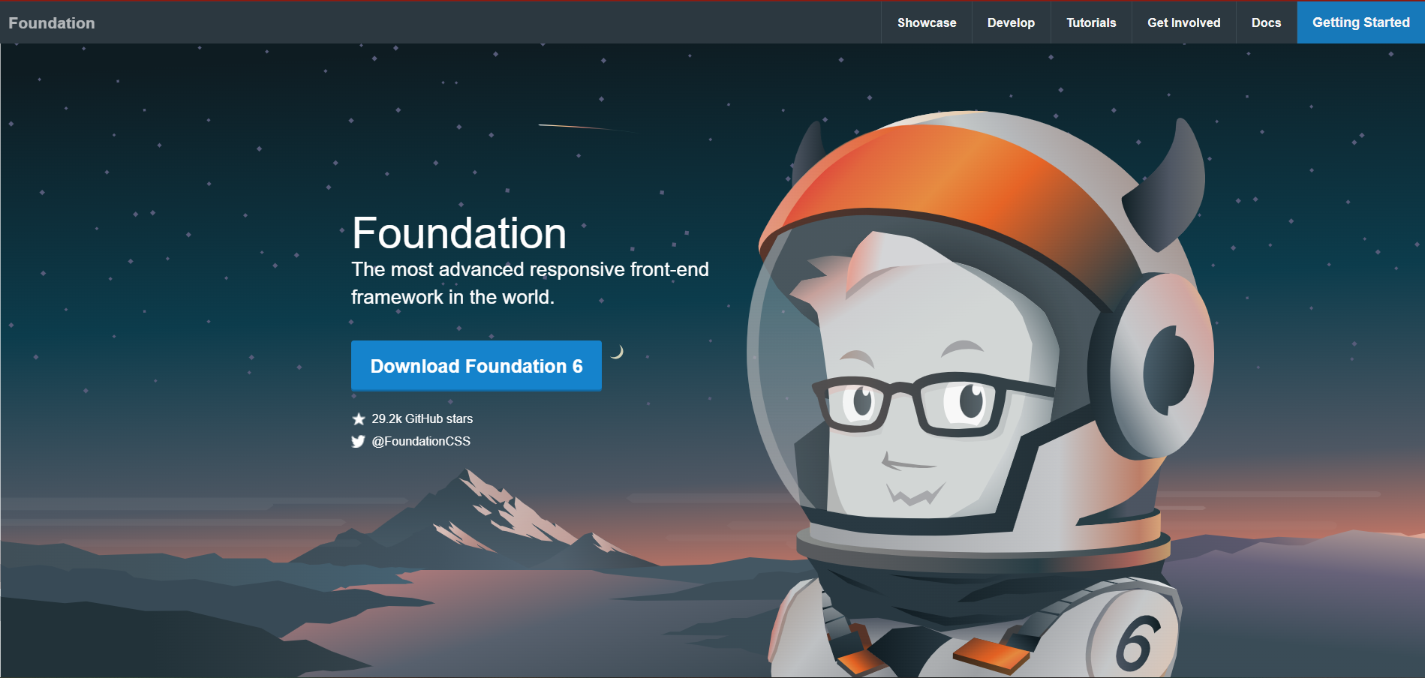

Figure 14: Foundation CSS (source: https://get.foundation/ )

Foundation is an open source and responsive framework [16] that makes it simple for users to create email interfaces and applications that work on any device. It is used and interested by many famous companies and brands like Adobe, Facebook, ... With framework based on Bootstrap and also comes with a command line interface that makes the website simple to use module. Foundation allows developers to build fully responsive web applications [17].

###### Feature of Foundation

* Grid and composition

Foundation has a powerful grid system and several UI elements that make it more comfortable and easy to use.

* Convenience of design

Diversity in design, Foundation provides users with responsive designs that can be applied to all devices.

* Optimization

Nowadays with the development of mobile devices, many frameworks have tried to develop their frameworks to work as strongly on as many mobile devices as possible. Foundation is no exception, Foundation has also supported and built mobile approaches.

* HTML templates

With a large amount of HTML templates provided, users can customize and extend their application to work better on more devices and create better products.

###### Advantage of Foundation

* Free and Good Community

Foundation is a free and open-source framework, so users can download and use it. Foundation also owns a large number of self-operated communities, so when users encounter difficulties, it is easy to overcome during use.

* Easy to use

While the Foundation framework is easy to use, it also requires a basic understanding of HTML and CSS.

* Various models

It offers various templates that you can use to make your website with much lesser effort.

* Good support for SASS

Foundation supports preprocessors like SASS and Compass, which makes development faster.

###### Disadvantage of Foundation

* Difficult for beginners

Although it is easy for users, it is very difficult for beginners without knowing basic HTML and CSS.

* Lack of support from the site

When users have difficulty, they often go to the homepage to seek help, but Foundation lacks support in Q&A (Questions and Answers) and forums.

* Less Themes

Foundation has a lot of templates but very few themes.

###### How to use Foundation CSS

Users can download it directly on the Foundation's homepage: foundation.zurb.com

When using the Foundation's template, users will see this code on Listing 11 in the HTML file.

<link rel="stylesheet"

href="https://cdn.jsdelivr.net/npm/foundation-sites@6.5.1/dist/css/foundation.min.css" integrity="sha256-1mcRjtAxlSjp6XJBgrBeeCORfBp/ppyX4tsvpQVCcpA= sha384-b5S5X654rX3Wo6z5/hnQ4GBmKuIJKMPwrJXn52ypjztlnDK2w9+9hSMBz/asy9Gw sha512-M1VveR2JGzpgWHb0elGqPTltHK3xbvu3Brgjfg4cg5ZNtyyApxw/45yHYsZ/rCVbfoO5MSZxB241wWq642jLtA==" crossorigin="anonymous">

Listing 11: How to use Foundation CSS

#### Advantage of CSS3

* Consistency

Users only need to use a single CSS file, all different pages in the same website will sync with each other. If the user wants to change, then just change the parameters and information in the CSS file, the website will sync again. That is the main advantage of CSS.

* Compatibility

CSS is compatible with many screens, so it will be more convenient for users without adjusting the displayed content, increasing the user experience.

* Easy to understand

Nowadays, users can learn and learn HTML and CSS on the internet. The layout and attribute information are clearly explained and easy to understand, making it easy for users to learn. CSS properties and HTML tags are separated by "class" and "id", which will not be confused by users.

* Common

CSS and HTML are languages ​​that are widely used and widely used in the world and are used in a number of browsers. Community is also one of the important factors for the maintenance and development of the language, HTML, CSS and JS are languages ​​with strong support communities in the world.

#### Disadvantage of CSS3

* Problems with some browsers

For some newer and less used browsers, there are some problems using CSS.

* Multiple CSS levels

There are three levels of CSS namely CSS, CSS2 and CSS3, which can be confusing for some newbies.

### JavaScript

#### What is JavaScript?

JavaScript is a dynamic programming language for creating content for web pages and is one of the most commonly used languages ​​in the world. JavaScript is integrated into HTML files, created to increase interactivity and improve website performance.

JavaScript creates web page effects such as dynamic background colors, animations, ...

#### Advantage of JavaScript

JavaScript is one of the most used programming languages ​​in web programming, it is almost an indispensable language in web programming, developers are always developing this programming language, helping to This language gradually becomes easier to use and more convenient for users.

* Execution on the client

When a user executes the code, the source code executes on the client machine instead of on the server server, saving bandwidth and interruption on the web server. Because if all the source code executes on the server, the server won't be able to process it in time.

* Simple language

JavaScript is a programming language that developers consider easy to learn. JavaScript uses the Virtual DOM to provide writing features for a variety of objects, making it easy for users to use and understand when dealing with a script.

* Quick interaction for users

When the user completes the code, the user can execute and the results are returned immediately. With fast results processing speed makes it easier for users to interact and does not consume a lot of time and data on the server and the client.

* Richer interface

JavaScript provides users with a variety of interfaces to be able to create attractive web pages such as Drag and Drop (DnD) components or sliders . Helps improve user-site interaction.

#### Disadvantage of JavaScript

* Other client-side security

When JavaScript code is executed on the client-side, the results are returned almost immediately, so preliminary information can be exploited with malicious intent, malicious code can still work on the client side. client machine.

* Browser support

JavaScript is one of the languages that is run on almost all browsers, but with very old browsers, sometimes it will not work, but this will not affect much if the user changes the browser or upgrade.

#### JavaScript Framework

Like CSS Framework, JS Framework is a pre-written code, it contains compilers, interpreters, libraries, etc. Users only need to understand the operation rules and call out the functions for easy use.

The benefit of using JS Framework is increased overall efficiency. JS Framework gives your project a more detailed structure, ready to provide common programming solutions. JS Framework has many different types of libraries and attracts a lot of users and developers like Angular, React, Vue, ...

##### React

Figure 15: React homepage

###### What is React?

React is the most popular JavaScript library for building user interfaces (UIs). It gives excellent response speed to user input using a new method of rendering web pages.

React components are developed by Facebook. It was launched as an open source JavaScript engine in 2013. It is now ahead of major competitors like Angular and Bootstrap, the two best-selling JS libraries of the time.

React is also one of the most commonly used and downloaded JS libraries, as well as one of the programming libraries that many companies require to recruit in some countries with high salaries.

###### Feature of React

* JSX

JSX stands for JavaScript XML, which is a syntactic extension of JavaScript. XML and HTML syntaxes are integrated and used by React, allowing users to create tags that function like HTML to display components. If users do not want to use JSX in ReactJS, users can use basic JavaScript to manipulate React.

* Components

React has a lot of components, each with its own logic and application, making it reusable and maintainable by users in large projects.

* Virtual DOM

The virtual DOM is a representation of the original DOM and acts as one-way data binding. React uses the virtual DOM to recreate components in the web application and user interface. If there is a change, the DOM will update the changes made by the user, making memory less wasted and working faster.

* React Native

React Native is a user interface framework built for creating mobile apps. With React Native, users can create applications on operating systems such as Android, iOS, and Windows. Similar to ReactJS, React Native is based on components that, when developed, create complete user interfaces. There are many applications using React Native on mobile devices such as Skype, Instagram, Facebook, ...

* Redux

Redux is a predictable state management tool for JS applications. It helps you write applications that work consistently, run in different environments, and are easy to test. Therefore, Redux is often used in combination with React.

###### Advantage of React

* Reuse

Components can be reused, eliminating the need for programmers to rebuild from scratch, and optimizing usage time.

* Big community

React has a large community that helps programmers get help, so if users encounter difficulties in the process of using React, the community is the place that can provide maximum support for users and solve them.

* Easy to use

With a large community, it is not difficult to learn how to use this library, as the documentation and information related to React is very popular and is widely taught at universities or on the internet.

* Simplicity

React uses JSX files, which makes the application simpler and easier to understand. If users know how to use JSX files, then the source code will be managed clearly and will be easy for readers to understand, and others can learn from that source code.

* Facebook

Because React is made by great Facebook developers. And React is also source code, so React will be supported and built by many developers behind. Therefore, React will be widely used by the community because of the support from the back-end developers.

###### Disadvantage of React

* Continuous updates

React is one of the frameworks that evolve very rapidly and continuously. Since React has always been built and supported by many great developers, there will always be a lot of changes and updates. Each update will have a change in programming, so it will be difficult for developers to access and update continuously. Because they always have to change their way of working when using React.

* Poor document

Because React updates constantly. Therefore, supporting documents and information cannot be updated in a timely manner. Since documents need to be thoroughly checked and correct, it also takes time to create new documents that are responsive to users.

* Unaccustomed to using JSX

React uses JSX. Since this is built-in syntax, not all developers can know how to use it. The fix for anyone who doesn't want to use JSX is to be able to use basic JavaScript for React, but if you do, your source code will become verbose.

##### Angular

Figure 16: Angular homepage

###### What is Angular?

AngularJS is one of the first frameworks born a long time ago, built and developed by the Google company, born in 2010. The birth of AngularJS2 has caused a controversy, because the structure and language of AngularJS2 is completely different. With the first version, maybe those who have learned AngularJS1 will have to learn from the beginning, but to versions 3,4,5,6, they will be gentler in using and learning. AngularJS has another language called TypeScript, a language like JavaScript but will be more structurally strict.

The popularity of AngularJS is not appreciated in terms of usage, but they have a strong enough community to be able to support and answer.

Angular is also focusing on stability and robustness through innovation and a perfect framework for enterprise application development.

###### Feature of Angular

* MVC

Angular provides developers to write applications in the MVC (Model-View-Controller) model. In Angular, when using the MVC pattern, developers can explicitly write other machine-side applications.

* Free

Angular is a free and open source code. Since it was released in 2010, there are already many long-time developers around the world using Angular, so users will also get answers from the community.

* Multi-platform

Angular is cross-browser compatible, so Angular can execute JavaScript code to work well on different browsers.

###### Advantage of Angular

* Increasing productivity

Angular has improved developers' performance by combining with Typescript, handling JavaScript limitations like data checking, ... helping developers understand their functionality as it does.

* Community and Documentation

Supported by Google and the Angular community, information and questions are posed and answered on the community sites. So, users will not be surprised when using. With the amount of documentation and libraries being constantly updated, Angular helps users save time coding and integrate more functions.

* Cross-browser compatibility

AngularJS is suitable for different browsers. AngularJS applications can run on most web browsers, Angular also supports mobile platforms including Android and IOs.

###### Disadvantage of Angular

* Unsafe

Because it is developed from JavaScript, Angular JS should have security and server-side validation that will make the application more secure.

##### Vue

Figure 17: Vue homepage

###### What is VueJS?

VueJS, as one of the frameworks developed by former Google employees, is one of the flexible frameworks that can handle many situations, which is the choice of many developers and programmers.

VueJS is a combination of many frameworks, and when building products, VueJS is very convenient when combined with other frameworks for development.

In many ways, it has become the middle way between React and Angular and provides a pleasant alternative to both Angular and React.

###### Feature of VueJS

###### Advantage of VueJS

* Easy to learn

Vue does not require too much in-depth knowledge, so it will be easier for beginners to get started than other frameworks.

* Virtual DOM

Similar to React, Vue.js uses the Virtual Document Object Model (DOM) to render views.

* Compatibility between frameworks

Vue's compatibility is highly appreciated by programmers. Because it allows you to write templates in HTML or JS. Vue's framework structure is quite similar to React and Angular, so you will also easily switch from React or Angular to Vue. Vue allows developers to add Vue CDN before starting the product because Vue CDN has a lot of libraries and components so when using it, there is no setup of nodes and npm.

* User Interface

Vue is a framework that has always focused on working with UI. This is possible because it only requires HTML, CSS and JS to work with it and doesn't rely on too much Vue-specific stuff.

###### Disadvantage of VueJS

* Language

Because Vue is a new framework, the community does not have many members, so when users have difficulties, the community will be less interactive and limited. Because Vue was developed by Chinese-Americans, Vue has a large number of non-English-speaking users

* Plugins.

Plugins available on Vue can be used with other frameworks that are not well supported. Since Vue has only recently evolved, if you are a new user, it is recommended to update regularly.

# WAY OF WEB APPLICATION DEVELOPMENT

## Operating system

Windows[23] is the most popular operating system for computers. Built and developed by Microsoft. This is the operating system that I use to make my project.

## Framework

### HTML5

HTML5 is a programming language developed on the basis of HTML language and most importantly of the World Wide Web (WWW). It is used to design and structure websites, support for maximum multimedia but still make the website friendly to all users and all devices, computer programs, web browsers… Compatibility HTML5's cross-browser compatibility is also an advantage of this language, making the website easy to use and interact well with users. HTML5 is also mobile-optimized, making it easier and clearer to display on mobile apps.

### ReactJS

ReactJS is an opensource developed by Facebook, launched in 2013, ReactJS is a Javascript library used to build interactions with components on the website. One of the most outstanding features of ReactJS is that rendering data can not only be done on the Server layer, but also below the Client.

ReactJS is a JavaScript library that specializes in helping developers build user interfaces or UIs. In front-end application programming, programmers will usually have to work on two main components: UI and handling user interaction. UI is the collection of components that you see on any application, examples can include: menus, search bar, buttons, cards, etc. Suppose you are programming a website. e-commerce, after the user chooses the product he likes and clicks the "Add to cart" button, the next thing you have to do is add the selected product to the cart and display the product again. that product when the user enters to view.

## SASS

SASS is a CSS preprocessor (CSS preprocessor). It helps you to write CSS in the way of a programming language, with a clear and concise structure, easier to develop and maintain the code. In addition, it has a lot of support libraries attached to help you write CSS code easily and simply. There are many types of CSS Preprocessors which include SASS, Stylus or LESS.

Sass stands for Syntactically Awesome Style Sheets, a preprocessor Scripting Language (Preprocessor Scripting Language) program that will be compiled into CSS. That is, I will style it with SASS, and then SASS will render my work into a CSS file.

## Tool and other software

### Redux

Redux is a predictable state management tool for JavaScript applications. It helps you write applications that work consistently, run in different environments (client, server, and native) and are easy to test. Redux was born inspired by the ideas of Elm language and Facebook's Flux architecture. Therefore, Redux is often used in combination with React.

When using a combination of Redux with ReactJS, states are not necessarily upgraded, which makes it easier for users to track changes in actions. Elements also won't use any states or methods to allow child elements to share data between them. When every process has Redux intervention, the application is simplified and easier to maintain.

### Photoshop

Photoshop is an important tool for designers, web developers, graphic artists, photographers, and other content creators. . They use Photoshop to retouch the image, cut out or clarify places in the image that are not clear. And web designers use Photoshop to build website interfaces, build banner images and content images in posts.

# CASE STUDY

Before implementing, a project or a certain product, we will design the product using Photoshop, Adobe UI / UX, ... The product images, logos, I had to use Adobe Photoshop application to adjust the images for the page web.

After performing the download of product images to make data on the page https://www.footshop.com/en/ . I have done the graphic design, by adjusting the size, frame, ... to fit the website.

I choose ReactJS as my main framework for designing my website. Because ReactJS is one of the frameworks used and developed by many developers. Besides, ReactJS is also one of the languages ​​preferred by companies and employers to hire and pay a higher salary than other frameworks.

My application is based on a sales website and I will apply some functions and applications to my website, and I will analyze each part that applies to my website.

The case study is based on popular or popular shoe management websites such as FootLocker, Nike, Addidas,... So, to complete a complete project, some of the features below will be referenced and introduced for project implementation.

## Index Page

First about the index page, because the table of contents page is very important, they will attract a lot of viewers and customers, with some items that will be introduced, introduced, discounted, etc. will be able to help. for customers. Customers are interested in the product, even though customers have many options on other websites, but when they see the attractiveness of the colorful and informative interface, they can still keep them.

Like the website of Bitis (bitis.com.vn), although the design is quite simple, when customers enter, they will be attracted by the image design for the product on the Carousel section. They can see, what items can make them buy immediately.

Besides, when the index page attracts customers, they will be willing to share with friends not only about the product, but also about the website such as beautiful, simple page design, with many options, …

On the homepage, after viewing the carousel, you can scroll down to see more outstanding products of men, women, ..., discount items according to events such as Independence Day or Black Friday , ...

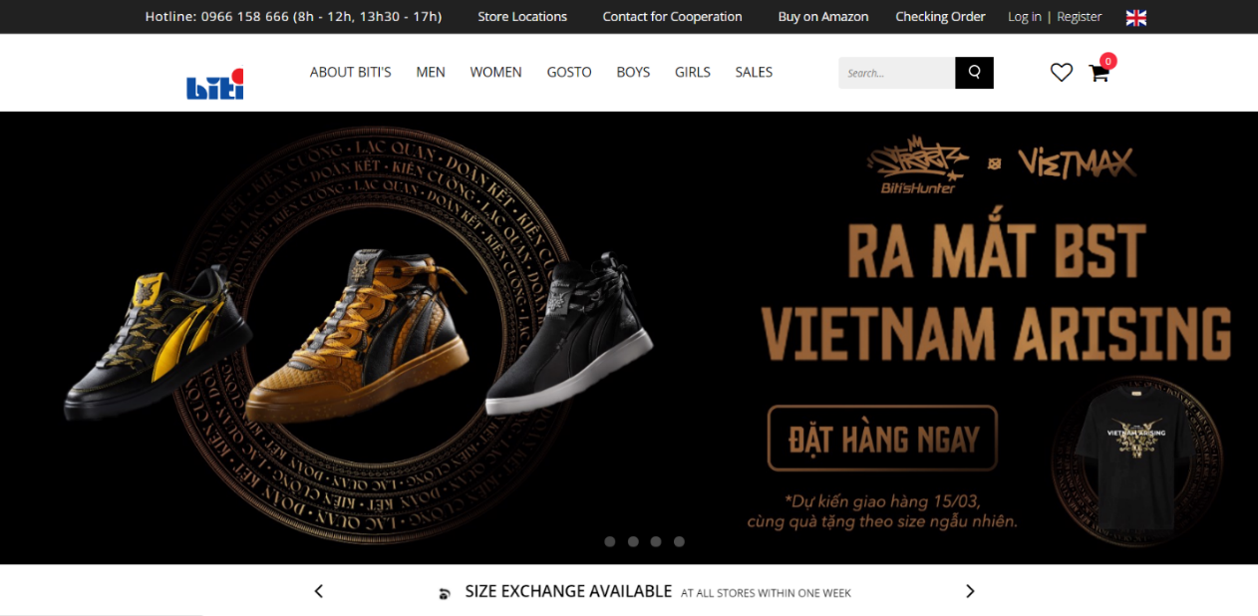Fig: Figure18: Home Page

## Product Page

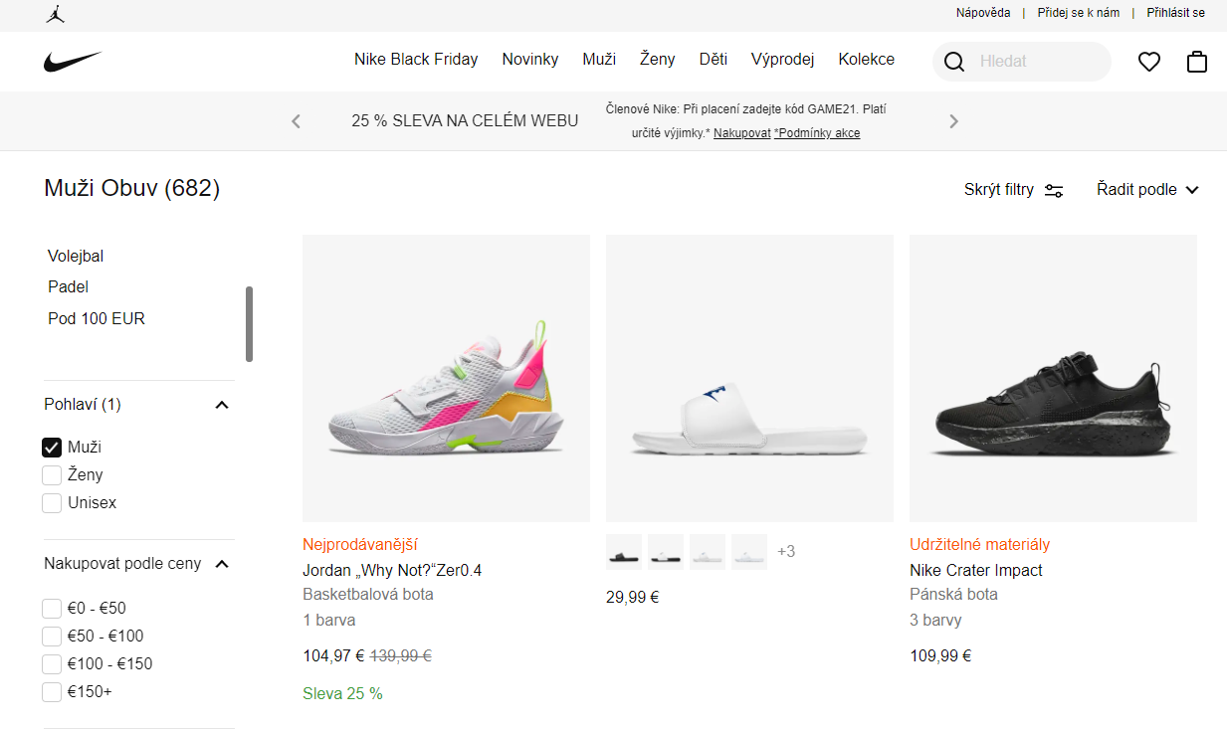On the product page, customers can choose the items they want to buy. Besides selecting items, users can filter out options to choose products according to their wishes. With many filter types such as Size, Brand, Product Type, .... there can be many choices to make.

Figure 19: Product Page

## Product Detail

On product cards, users can point the mouse to see image changes to see details and have more options to consider product perspectives.

In the detailed product section, customers can view product details with many possible contents such as size or color, customers can click the button left or right to see more corner groups about the product they want to buy, along with some add-to-cart features if you want to buy, can help 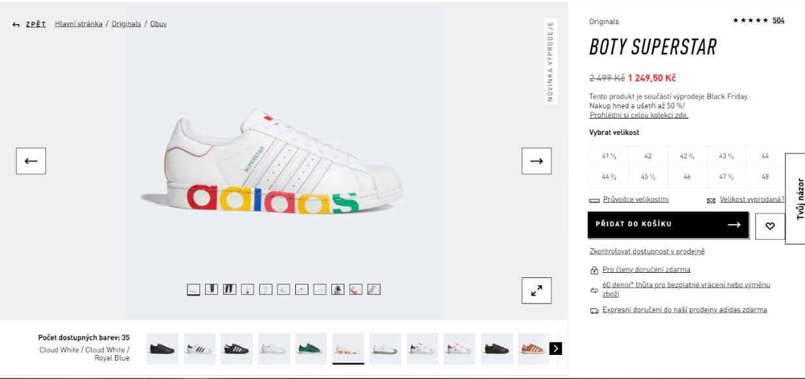customers choose products without having to go to the store branch to try.

Figure 20: Product Detail

## Cart Page

After they add products to the cart, the basket will count the number of products that have been added to calculate the quantity that the customer has selected.

On the checkout page, customers will see the amount and total product they have selected, customers can delete the product if they don't want to buy that product anymore and proceed to pay.

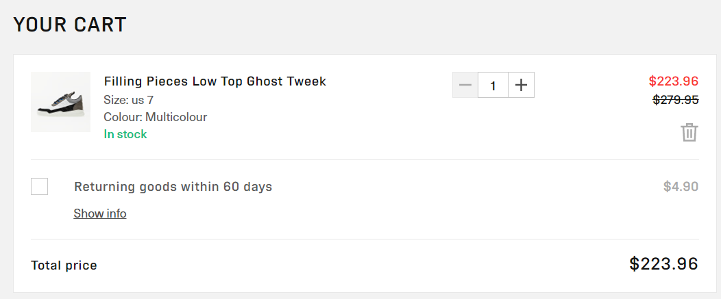

Figure 21: Cart Page

# IMPLEMENTATION

To start building the website, we should use the command line and type the syntax: npx create-react-app [name-project] to create a project using ReactJS framework.

It's up to the user who wants to use CSS or SASS. But I will use SASS.

Users can use Visual Studio Code, to be able to make web building easier, more convenient and faster. I will introduce some of the main functions of my website. My website, consists of 8 pages, but I will recommend 4 pages, because these are the 4 main and important pages of the website. In all pages, the default 2 components are Header and Footer, because they always appear in the whole page.

In this project, ReactJS can divide a page into many components, users can reuse these components to connect other pages. This is the convenience that React brings to users to avoid wasting time creating new and repeating projects for the project.

## Index page

In the index page, the function used for this page is the carousel, along with some elements specifically created to combine with the home page.

The user can click left and right to see the effect and turn pages in the carousel.

And the carousel tag is a component created specifically to save space for the home page, easy to use and easy to fix if there is an error.

 <Carousel

                data={heroSliderData}

                control={true}

                auto={false}

                timeOut={5000}

            />

Listing 10: Carousel in homepage

In the Carousel component, the functions are set up so that the user can press the left and right buttons to switch pages. And create the function to automatically turn pages in 3-4 seconds. So while users, are viewing products or reading information in the Carousel, the time setting is automatic, but the user does not need to click to switch pages, making it easier for users to read themselves.

const data = props.data

    /*set time for carousel*/

    const timeOut = props.timeOut ? props.timeOut : 3000

    const [activeSlide, setActiveSlide] = useState(0);

    /*next carousel*/

    const nextSlide = useCallback(

        () => {

            const index = activeSlide + 1 === data.length ? 0 : activeSlide + 1

            setActiveSlide(index)

        },

        [activeSlide, data],

    )

    /*previous carousel*/

    const prevSlide = () => {

        const index = activeSlide - 1 < 0 ? data.length - 1 : activeSlide - 1

        setActiveSlide(index)

    }

    /*set auto turn next carousel*/

    useEffect(() => {

        if (props.auto) {

            const slideAuto = setInterval(() => {

                nextSlide()

            }, timeOut);

            return () => {

                clearInterval(slideAuto)

            }

        }

    }, [nextSlide, timeOut, props])

Listing 11: Carousel component

In the Home page, there will be products, posters, and policies. In the product section, the product will appear randomly, each time the page reloads, a different product will appear.

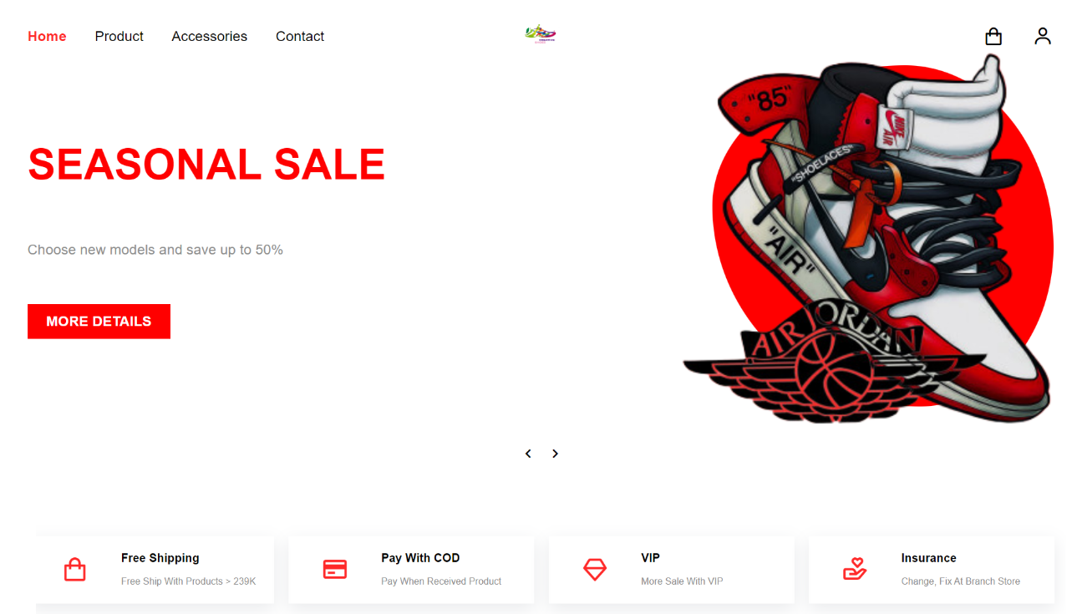Figure : Carousel and Policy card

## Product page

In the product page, there will be the main components: filter, product card, product view mini.

In the filter, users will be able to select the products they want to choose, prioritize products through the filter. There are 3 types of filters in the product page, which are Brands, Colors, Size, the more filters you choose, the more products customers want to get will appear.

const initFilter = {

        category: [],

        color: [],

        size: []

    }

    const productList = productData.getAllProducts()

    const [products, setProducts] = useState(productList)

    const [filter, setFilter] = useState(initFilter)

    const filterSelect = (type, checked, item) => {

        if (checked) {

            switch(type) {

                case "CATEGORY":

                    setFilter({...filter, category: [...filter.category, item.categorySlug]})

                    break

                case "COLOR":

                    setFilter({...filter, color: [...filter.color, item.color]})

                    break

                case "SIZE":

                    setFilter({...filter, size: [...filter.size, item.size]})

                    break

                default:

            }

        } else {

            switch(type) {

                case "CATEGORY":

                    const newCategory = filter.category.filter(e => e !== item.categorySlug)

                    setFilter({...filter, category: newCategory})

                    break

                case "COLOR":

                    const newColor = filter.color.filter(e => e !== item.color)

                    setFilter({...filter, color: newColor})

                    break

                case "SIZE":

                    const newSize = filter.size.filter(e => e !== item.size)

                    setFilter({...filter, size: newSize})

                    break

                default:

            }

        }

    }

Listing : Filter Function

Use a loop to create a selectable filter list, and this is done in HTML.

category.map((item, index) => (

<div key={index} className="catalog__filter__widget__content__item">

<CheckBox label={item.display}

            onChange={(input) => filterSelect("CATEGORY", input.checked, item)}

                      checked={filter.category.includes(item.categorySlug)}/>

      </div>

))

Listing : Loop filter to show

In the product page, the products will be displayed using the product card component. In Product Card, just create how one product tag will show on website, after creating tag just add ProductCard component to Product Page, it will show up on web page, but if want to show multiple products product then creates a list of products in a JavaScript file and loops in the Product Page to display all the products that have been created in the list.

                {

                    data.map((item, index) => (

                        <ProductCard

                            key={index}

                            img01={item.image01}

                            img02={item.image02}

                            name={item.title}

                            price={Number(item.price)}

                            slug={item.slug}

                        />

                    ))

}

Listing : Loop Product Card to show on Product page

        <div className="product-card">

            <Link to={`/catalog/${props.slug}`}>

                <div className="product-card__image">

                    <img src={props.img01} alt="" />

                    <img src={props.img02} alt="" />

                </div>

                <h3 className="product-card__name">{props.name}</h3>

                <div className="product-card__price">

                    {numberWithCommas(props.price)}

                    <span className="product-card__price__old">

                        <del>{numberWithCommas(9900)}</del>

                    </span>

                </div>

            </Link>

            <div className="product-card__btn">

                <Button

                    size="sm"

                    icon="bx bx-cart"

                    animate={true}

                    onClick={() => dispatch(set(props.slug))}

                >

                    Buy

                </Button>

            </div>

        </div>

Listing : Product Card component

const products = [

    {

        title: "ADIDAS SUPERNOVA CUSHION 7",

        price: '4000',

        image01: product_01_img01,

        image02: product_01_img02,

        categorySlug: "adidas",

        colors: ["white", "red", "orange"],

        slug: "ADIDAS-SUPERNOVA-CUSHION-7",

        size: ["s", "m", "l", "xl"],

        description: "Create by Adidas"

    }

]

Listing : Create list of product

In Button, when you move the cursor to the Buy Now button, the word Buy Now will become a shopping cart icon. This is the effect applied to create beauty and attract users. In the button, use dispatch to props to determine the state and return the page for that product.

                <Button

                    size="sm"

                    icon="bx bx-cart"

                    animate={true}

                    onClick={() => dispatch(set(props.slug))}

                >

                    Buy

                </Button>

Listing : Button on ProductCard component

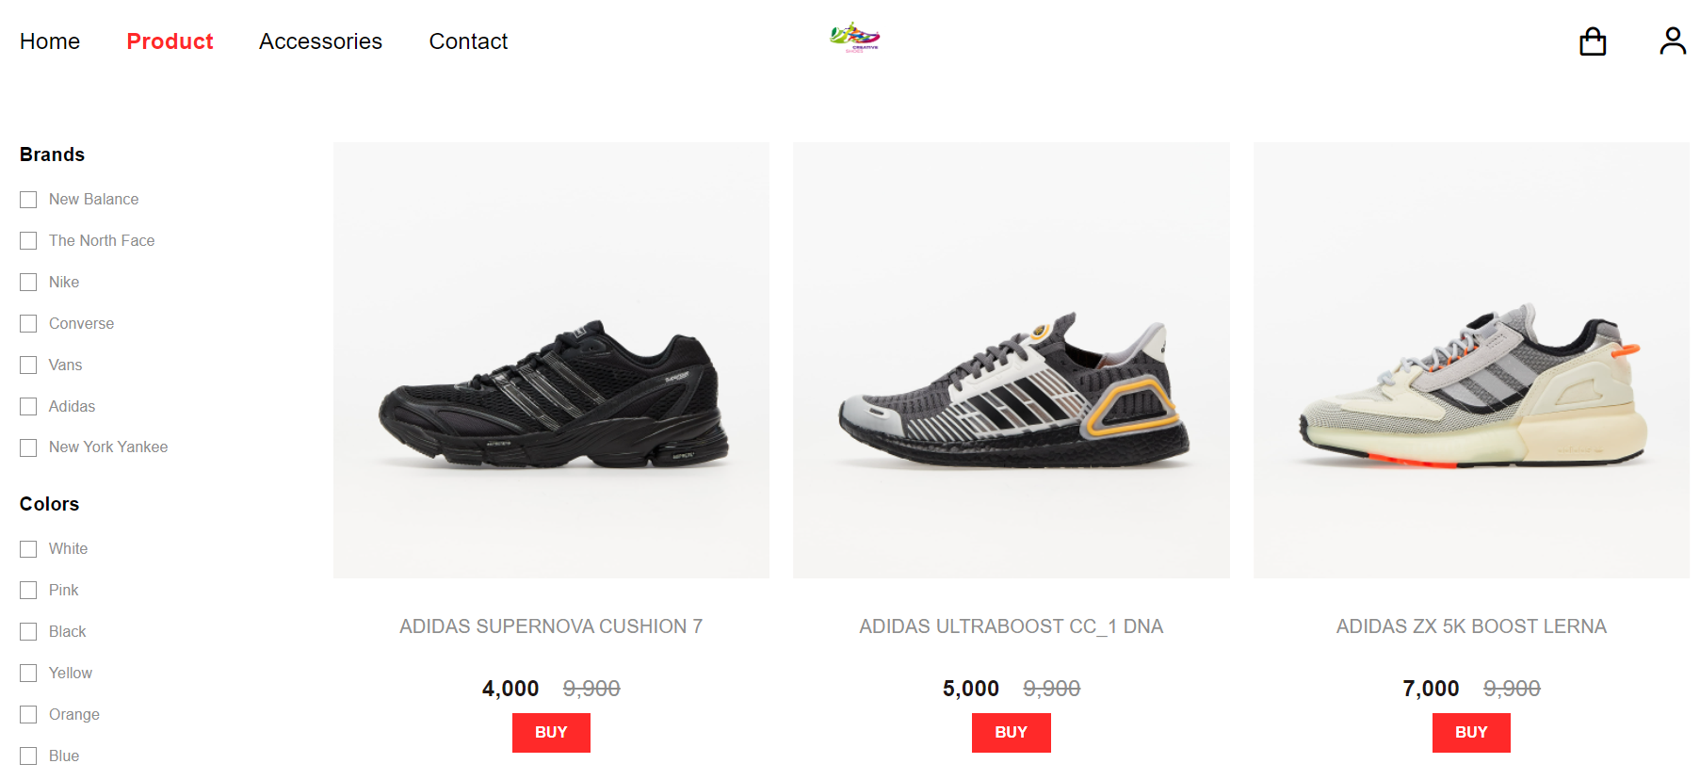

Figure : Product Page

## Detail page

In the product detail page, I have set the value to slug, when the user clicks on any product, the link will show the product name in that link without having to initialize hundreds of links if any. hundreds of products. Just attach the value 'slug' in each product and create the link in the Route tag in 1 line: <Route path='/catalog/:slug' component={Product}/>

In product detail, the website will appear product information such as title, color, size, quantity, button ... And when scoll to see information about shoes, the information item will move until the end of the section 'see more'. And the customer will be able to see the related products if the customer no longer wants to buy the current product.

    const product = productData.getProductBySlug(props.match.params.slug)

    const relatedProducts = productData.getProducts(8)

    React.useEffect(() => {

        window.scrollTo(0,0)

    }, [product])

Listing : Product for scrolling and related products

Users will have to choose enough color, size and quantity to add products to the cart, if the user does not choose a color or size, warning lines will appear.

    const check = () => {

        if (color === undefined) {

            alert('Please Choose Colors!')

            return false

        }

        if (size === undefined) {

            alert('Please Choose Sizes!')

            return false

        }

        return true

    }

Listing : Alert

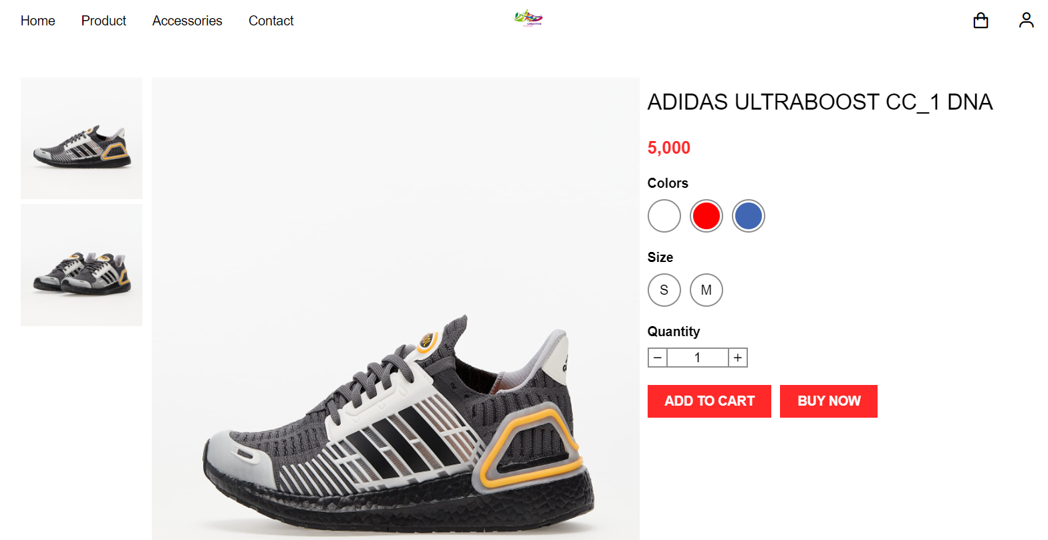

Figure: Product Detail

## Cart page

After the customer chooses to buy the product, the product will be added to the cart. But in order to be able to store it in the cart and be able to update it if you buy a lot or delete products, in React you should use createSlice in Redux. createSlice is a function that deals with everything you need for each slice, an object of reducer functions. This API is the approach to writing Redux logic.

export const cartItemsSlice = createSlice({

    name: 'cartItems',

    initialState,

    reducers: {

        addItem: (state, action) => {

            const newItem = action.payload

            const duplicate = state.value.filter(e => e.slug === newItem.slug && e.color === newItem.color && e.size === newItem.size)

            if (duplicate.length > 0) {

                state.value = state.value.filter(e => e.slug !== newItem.slug || e.color !== newItem.color || e.size !== newItem.size)

                state.value = [...state.value, {

                    id: duplicate[0].id,

                    slug: newItem.slug,

                    color: newItem.color,

                    size: newItem.size,

                    price: newItem.price,

                    quantity: newItem.quantity + duplicate[0].quantity

                }]

            } else {

                state.value = [...state.value, {

                    ...action.payload,

                    id: state.value.length > 0 ? state.value[state.value.length - 1].id + 1 : 1

                }]

            }

            localStorage.setItem('cartItems', JSON.stringify(state.value.sort((a, b) => a.id > b.id ? 1 : (a.id < b.id ? -1 : 0))))

        },

        updateItem: (state, action) => {

            const newItem = action.payload

            const item = state.value.filter(e => e.slug === newItem.slug && e.color === newItem.color && e.size === newItem.size)

            if (item.length > 0) {

                state.value = state.value.filter(e => e.slug !== newItem.slug || e.color !== newItem.color || e.size !== newItem.size)

                state.value = [...state.value, {

                    id: item[0].id,

                    slug: newItem.slug,

                    color: newItem.color,

                    size: newItem.size,

                    price: newItem.price,

                    quantity: newItem.quantity

                }]

            }

            localStorage.setItem('cartItems', JSON.stringify(state.value.sort((a, b) => a.id > b.id ? 1 : (a.id < b.id ? -1 : 0))))

        },

        removeItem: (state, action) => {

            const item = action.payload

            state.value = state.value.filter(e => e.slug !== item.slug || e.color !== item.color || e.size !== item.size)

            localStorage.setItem('cartItems', JSON.stringify(state.value.sort((a, b) => a.id > b.id ? 1 : (a.id < b.id ? -1 : 0))))

        },

    },

})

export const { addItem, removeItem, updateItem } = cartItemsSlice.actions

Listing : createSlice for adding, removing and updating in Cart page.

In the Cart Page, besides functions like Add, Update and Remove item. Then there will be equally important functions, which are displaying product information, calculating the total number of items and calculating the total amount of products in the cart and basic buttons such as returning to the home page or continuing to checkout.

    const cartItems = useSelector((state) => state.cartItems.value)

    const [cartProducts, setCartProducts] = useState(productData.getCartItemsInfo(cartItems) || productData1.getCartItemsInfo(cartItems))

    const [totalProducts, setTotalProducts] = useState(0)

    const [totalPrice, setTotalPrice] = useState(0)

    useEffect(() => {

        setCartProducts(productData.getCartItemsInfo(cartItems) || productData1.getCartItemsInfo(cartItems))

        setTotalPrice(cartItems.reduce((total, item) => total + (Number(item.quantity) * Number(item.price)), 0))

        setTotalProducts(cartItems.reduce((total, item) => total + Number(item.quantity), 0))

    }, [cartItems])

Listing : Total product and price

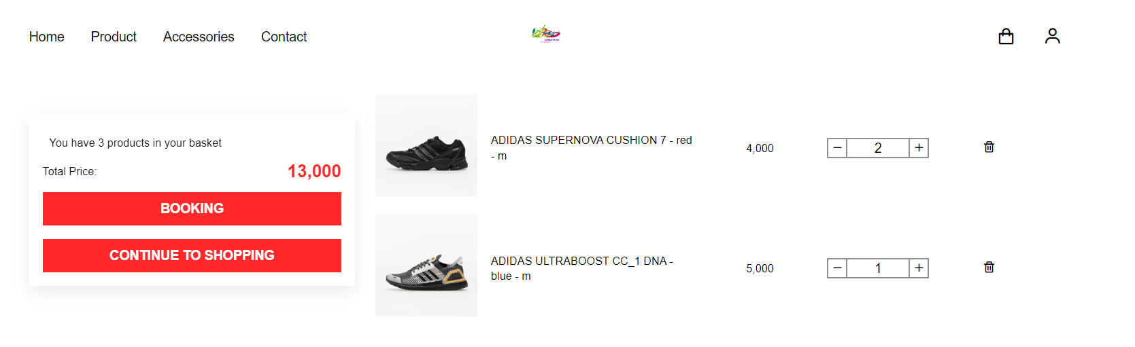

Figure : Cart page

## Other Important Components

### Layout

Layout is one of the important components, because this is a component used to manage other components and interfaces, and these are usually default components like Header, Footer and just change pages together like Home, Product, ... Components such as Header, Footer have been built and set up before and only need to be attached to the Layout page to activate the interface.

        <BrowserRouter>

            <Route render={props => (

                <div>

                    <Header {...props}/>

                    <div className="container">

                        <div className="main">

                            <Routes/>

                        </div>

                    </div>

                    <Footer/>

                    <ProductViewModal/>

                </div>

            )}/>

        </BrowserRouter>

Listing : Layout

### Header

In the Header, the small elements are listed with the role of being able to move from one page to another, and they are the button used to switch pages, have been enumerated and invoked in the loop.

/* main page*/

const mainNav = [

    {

        display: "Home",

        path: "/"

    },

    {

        display: "Product",

        path: "/catalog"

    },

    {

        display: "Accessories",

        path: "/accessories"

    },

    {

        display: "Contact",

        path: "/contact"

    }

]

Listing : Set up list page will display

When the user scrolls the mouse moves up and down, the mainbar will also move. 'Shrink' will be executed when scrolling down. If it returns to the top of the page, 'Shrink' will not execute and stick to the page.

    /*when scroll down, header will go page*/

    useEffect(() => {

        window.addEventListener("scroll", () => {

            if (document.body.scrollTop > 80 || document.documentElement.scrollTop > 80) {

                headerRef.current.classList.add('shrink')

            } else {

                headerRef.current.classList.remove('shrink')

            }

        })

        return () => {

            window.removeEventListener("scroll")

        };

    }, []);

Listing : Header will go when scroll down



Figure : Header component

### Footer

Footer like Header is used for footer and this is the default page, always appearing on all pages. The important function of this page is to read the list of pages that will be displayed on the web. The remaining functions such as displaying the logo and information about the page, ...



Figure: Footer component

# EVALUATION

This is a pretty basic ReactJS project. According to personal assessment, ReactJS is not too difficult to use, but to master it, you have to spend a lot of time and do many projects related to ReactJS, it will help users more.

ReactJS will have a lot of uses and combinations with different tools and frameworks. Users can use JSX instead of JS, although both can work on ReactJS but JSX will be a neat file, easy to program, requires thoughtfulness in the project will make the project look good and The code will be easier to understand. JS is usable in React but managing and organizing the source code will be a bit confusing because if you don't know how to organize and it also becomes more confusing because it is not shortened.

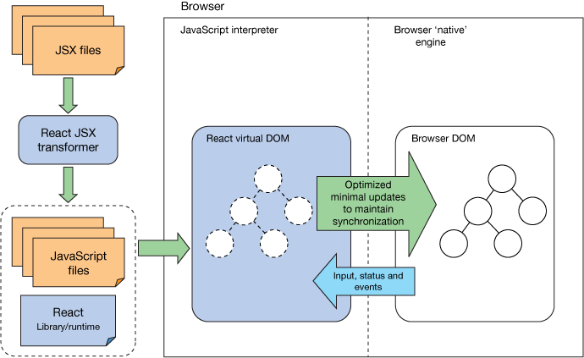

Figure : React operations

In the field of technology development, business owners and developers are always looking for the best methods to give their businesses a better competitive edge. And one of the best technologies that can help businesses stay ahead of the competition in creating web applications is ReactJS.

ReactJS allows businesses to create web applications with better UI to enhance user experience. This is also the technology that businesses need to get higher user engagement, click-through rates and conversions. Moreover, businesses using ReactJS are guaranteed to have a better interface than those using other frameworks because ReactJS helps prevent DOM updates for faster applications and better UX delivery.

Facebook and the entire ReactJS team have always strived to demonstrate their commitment to making ReactJS more efficient. This is a prerequisite to overcome the rapid development of other frameworks like Vue.js.

Although ReactJS has certain limitations, but I believe in the future, ReactJS will be able to handle these limitations, because with a large community coming from all over the world, ReactJS will grow more and more, New users will gradually increase and grow quickly.

# CONCLUSION

In this bachelor thesis, I analyzed, designed and implemented the Shoe Shop website. In the analysis section, I read through many research papers on the technique, the market and the differences between the frameworks. During the analysis, I learned and researched how to use React along with some other tools, I designed a basic Shoe Shop website for users to view, refer to and increase the user experience. use. In terms of interface, I may not have designed the full functionality of a Shoe Shop website, but I believe the important features like add to cart, calculation, filter, ... along with some The design of the colors, the position of the components,... has been fully designed and can be used by new users. Since I only focus heavily on Front-end, some basic functionality may not be provided. When users refer to this website, they will also understand the usefulness and simplicity so that users can download further development depending on their logic.

Since I focus a lot on React's Front-end, I didn't generate the Back-end data, the product data I generate manually in React. And I learned how to use Redux tool in combination with React and understand the value it brings.

Development of Modern Web Applications is a very interesting topic that helps me to learn a lot about frameworks in JavaScript. Although, there are many shortcomings in this project, but I believe, I will improve my work in the future. And the result I bring in this thesis, is to provide users with a view of frameworks so that users can choose the right framework for them. When I choose React as my main framework for designing a Shoe Shop website, I hope many users will see how I have designed and understand how I have implemented it and consider React as a language. suitable language or not. Web programming is one of the technologies chosen by people and in the future not only React but also many other frameworks will gradually appear and bring users the most convenient things when designing a website.

**REFERENCES**

[1]: Domantas G: The Differences Between HTML and HTML5. Last updated on: April 14, 2022. Available from: <https://www.hostinger.com/tutorials/difference-between-html-and-html5>

[2]: GeeksforGeeks: Top 10 new features of HTML5. Last updated on: March 15, 2021. Available from:

<https://www.geeksforgeeks.org/top-10-new-features-of-html5/>

[3]: Codecademy Team: HTML5 Features. Available from: <https://www.codecademy.com/article/html5-features>

[4]: W3School: HTML Canvas Graphics. Available from: <https://www.w3schools.com/html/html5_canvas.asp>

[5]: W3School: HTML Video. Available from: https://www.w3schools.com/html/html5_video.asp

[6];

[7]: Wikipedia: CSS. Available from: https://en.wikipedia.org/wiki/CSS

[8]: W3C: HTML & CSS. Available from: https://www.w3.org/standards/webdesign/htmlcss#whatcss

[9]: W3School: CSS Animation. Available from: <https://www.w3schools.com/css/css3_animations.asp>

[10]:

[11]: Tailwindcss Document: Available from: <https://tailwindcss.com/docs/installation>

[12]:

[13]: Jordana A.: What is Bootstrap?. Last updated on: March 18, 2022. Available from: <https://www.hostinger.com/tutorials/what-is-bootstrap/>

[14]: Jerome Davidson: 7 New Features to Look Out For in Bootstrap 5. Last updated on: April 20, 2021. Available from: <https://www.makeuseof.com/new-features-to-look-out-for-in-bootstrap-5/>

[15]:

[16]: GeeksforGeeks: Foundation CSS Introduction. Last updated on: February 14, 2022. Available from: <https://www.geeksforgeeks.org/foundation-css-introduction/>

[17]: Foundation About: A Yeti’s Trek. Last researched on April 10, 2022. Available from: <https://get.foundation/showcase/about.html>

[18]: Foundation 4 Documentation: Getting Started. Researched on: April 15,2022. Available from: <https://dracos.github.io/foundation-sites/>

[19]: GeeksforGeeks: Advantages and Disadvantages of CSS. Last updated on: November 23, 2020. Available from: <https://www.geeksforgeeks.org/advantages-and-disadvantages-of-css/>

[20]: Wikipedia: JavaScript. Researched on: April 17, 2022. Available from: https://en.wikipedia.org/wiki/JavaScript

[21]:

[22]:

[23]: JavaTpoint: What is Windows?. Research on: April 18, 2022. Available from: <https://www.javatpoint.com/windows>

<https://towardsdatascience.com/top-10-in-demand-web-development-frameworks-in-2021-8a5b668be0d6>

<https://www.lambdatest.com/blog/top-21-web-development-trends-in-2021/>

<https://clockwise.software/blog/web-development-trends/>

<https://www.valuecoders.com/blog/technology-and-apps/10-top-web-development-frameworks-businesses/#_2_Blockchain>

<https://designmodo.com/web-design-trends-2021/>

<https://www.mobindustry.net/blog/26-hot-web-technologies-and-web-design-trends/>

<https://reactjs.org/docs/create-a-new-react-app.html>

library: <https://jquense.github.io/react-big-calendar/examples/index.html>

https://medium.com/@smeyradvrn/support-multi-language-with-react-i18next-in-create-react-app-e10d2fafd36e